Below is a **complete, in-depth explanation of Amazon AWS** focused specifically on **Parallel and Distributed Computing**, written for **students, exams, and real-world understanding**, with **clear examples and architecture**.

**What is Amazon AWS? (Parallel & Distributed Computing)**

**1. Definition of Amazon AWS**

**Amazon Web Services (AWS)** is a **cloud computing platform** that provides **on-demand computing resources** such as servers, storage, databases, networking, and analytics over the internet.

**One-line definition (exam-ready):**

**Amazon AWS is a cloud computing platform that enables scalable parallel and distributed computing by providing on-demand infrastructure and services over the internet.**

**2. Why AWS is Important for Parallel & Distributed Computing**

Traditional computing problems:

* Limited hardware
* High cost of supercomputers
* Difficult scalability
* Manual maintenance

AWS solves this by:

* Providing **thousands of servers on demand**
* Supporting **parallel execution**
* Enabling **distributed systems**
* Charging **pay-as-you-go**

**3. What Type of System is AWS?**

AWS supports:

* **Distributed Computing**
* **Parallel Computing**
* **High Performance Computing (HPC)**
* **Cloud Computing**

⚠️ AWS is **not a programming language**  
✔ AWS is a **cloud service platform**

**4. AWS Cloud Computing Model**

**Service Models**

| **Model** | **Description** |
| --- | --- |
| IaaS | Virtual machines, storage, networking |
| PaaS | Managed platforms |
| SaaS | Ready-to-use software |

AWS mainly provides **IaaS and PaaS** for parallel/distributed computing.

**5. AWS Global Architecture**

AWS is globally distributed:

AWS Global Infrastructure

├── Regions

│ ├── Availability Zones

│ │ ├── Data Centers

**Why this matters:**

* Fault tolerance
* High availability
* Distributed execution
* Low latency

**6. Core AWS Services for Parallel & Distributed Computing**

**6.1 Amazon EC2 (Elastic Compute Cloud)**

**What it is:**

* Virtual servers in the cloud

**Role in Parallel Computing:**

* Run multiple EC2 instances simultaneously
* Each instance handles part of computation

**Example:**

Parallel image processing:

* Image set divided into chunks
* Each EC2 instance processes one chunk
* Results combined

**6.2 Auto Scaling**

* Automatically adds/removes servers
* Enables dynamic parallelism

**Example:**

* 10 servers at low load
* 1,000 servers during peak computation
* Back to 10 after completion

**6.3 Elastic Load Balancer (ELB)**

* Distributes workload across servers
* Ensures no single server overloads

**6.4 Amazon S3 (Simple Storage Service)**

* Distributed object storage
* Stores huge datasets
* Highly durable (99.999999999%)

**Example:**

* Input data stored in S3
* EC2 instances read data in parallel
* Output stored back in S3

**6.5 Amazon Lambda (Serverless Parallel Computing)**

* Executes code without servers
* Thousands of functions run in parallel

**Example:**

1,000 files uploaded → 1,000 Lambda functions triggered

Each processes one file independently

Perfect for:

* Embarrassingly parallel problems

**6.6 Amazon ECS / EKS (Container-Based Computing)**

* Distributed microservices
* Container orchestration
* Parallel workloads using Docker containers

**6.7 AWS Batch (HPC & Parallel Jobs)**

Designed specifically for:

* Parallel jobs
* Batch processing
* Scientific workloads

**Example:**

* Genome analysis
* Monte Carlo simulations
* Financial risk modeling

**7. Distributed Computing Example (Step-by-Step)**

**Example: Distributed Log Processing**

1. Logs stored in Amazon S3
2. Hundreds of EC2 instances launched
3. Each instance processes part of logs
4. Results aggregated
5. Output stored in database

AWS handles:

* Resource provisioning
* Fault tolerance
* Scalability

**8. Parallel Computing Example (Numerical)**

**Matrix Multiplication on AWS**

* Matrix split into blocks
* Each EC2 instance multiplies one block
* Results merged

This achieves:

* Faster execution
* Better CPU utilization

**9. Fault Tolerance & Reliability**

AWS provides:

* Multi-zone execution
* Automatic failure recovery
* Data replication

Example:

* If one server fails, AWS replaces it automatically

**10. Security in AWS Distributed Systems**

* IAM (Identity & Access Management)
* Encryption at rest and in transit
* Network isolation (VPC)

**11. Advantages of AWS for Parallel & Distributed Computing**

* Massive scalability
* No upfront hardware cost
* Global distribution
* High reliability
* On-demand resources

**12. Limitations of AWS**

* Cost management required
* Internet dependency
* Vendor lock-in risk
* Learning curve

**13. AWS vs Traditional Systems**

| **Feature** | **AWS** | **Traditional Cluster** |
| --- | --- | --- |
| Scalability | Very high | Limited |
| Cost | Pay-as-you-go | High upfront |
| Maintenance | AWS-managed | User-managed |
| Fault tolerance | Built-in | Manual |

**14. Real-World Use Cases**

* Netflix (distributed streaming)
* Scientific research
* Weather forecasting
* AI/ML training
* Big data analytics

**15. Exam-Oriented Summary**

**Keywords:**

* Cloud computing
* EC2
* S3
* Lambda
* Auto Scaling
* Distributed systems

**One-Paragraph Answer:**

Amazon AWS is a cloud computing platform that provides scalable infrastructure and services for parallel and distributed computing. It enables users to run multiple computing tasks simultaneously across geographically distributed data centers using services such as EC2, S3, Lambda, and AWS Batch.

If you want, I can next:

* Compare **AWS vs Globus vs Condor**
* Provide **numerical problems**
* Explain **AWS architecture diagram**
* Give **short notes & MCQs for exams**

Just tell me.

Great! Let’s break it down step by step.

**AWS vs Globus vs Condor (Parallel & Distributed Computing)**

Here’s a **detailed comparison** to understand where each is used, how they differ, and their strengths.

**1. Type & Purpose**

| **Feature** | **AWS** | **Globus** | **Condor** |
| --- | --- | --- | --- |
| Type | Cloud platform | Middleware toolkit | Job scheduler (HTCondor) |
| Purpose | On-demand scalable computing & storage | Grid computing, secure resource sharing | High-throughput job execution on idle resources |
| Focus | Parallel & distributed computing via cloud | Distributed resource management | Parallel tasks over idle machines |

**2. Architecture**

| **Feature** | **AWS** | **Globus** | **Condor** |
| --- | --- | --- | --- |
| Layers | Regions → Availability Zones → Services (EC2, S3, Lambda) | Fabric → Connectivity → Resource → Collective → Application | Submit node → Central manager → Execute nodes |
| Resource Management | Auto-scaling, load balancing | Resource discovery & scheduling | Central manager (collector + negotiator) |
| Security | IAM, encryption, network isolation | Grid Security Infrastructure (GSI) | User authentication, job permissions |

**3. Parallel & Distributed Computing Support**

| **Feature** | **AWS** | **Globus** | **Condor** |
| --- | --- | --- | --- |
| Parallelism | EC2, Lambda, Batch, ECS | Task-level parallel jobs using Grid middleware | Multiple independent jobs across nodes |
| Distributed Computing | Across regions, zones, and multiple data centers | Across organizations & grids | Across idle heterogeneous machines |
| Job Migration | Auto-scaling replaces failed instances | Depends on job & middleware setup | Suspends/migrates jobs if node becomes busy |

**4. Data Management**

| **Feature** | **AWS** | **Globus** | **Condor** |
| --- | --- | --- | --- |
| Storage | S3, EBS, RDS | GridFTP | Local / network file system |
| Data Transfer | High-speed, distributed, parallel | GridFTP (secure & parallel) | Manual or via scripts |
| Fault Tolerance | Built-in replication & multi-zone | Middleware handles some failures | Checkpointing & job retries |

**5. Advantages**

**AWS**

* Massive scalability
* Global infrastructure
* On-demand parallelism
* Fault tolerant
* Multi-purpose (storage, compute, AI/ML, analytics)

**Globus**

* Strong security (GSI)
* Standardized middleware
* Resource sharing across organizations
* High reliability for grid computing

**Condor**

* Utilizes idle machines
* High-throughput job execution
* Fault tolerant & migrates jobs
* Open source and lightweight

**6. Limitations**

**AWS**

* Cost management needed
* Internet-dependent
* Vendor lock-in

**Globus**

* Complex to configure
* Mostly research/academic use
* Heavyweight

**Condor**

* Not for tightly coupled parallel tasks
* Setup can be tricky
* Less suitable for massive data transfer

**7. Example Use Cases**

| **Platform** | **Example** |
| --- | --- |
| AWS | Netflix streaming (distributed), AI/ML training, Big Data analytics |
| Globus | Scientific research collaborations, grid-based simulations, secure data sharing between universities |
| Condor | Monte Carlo simulations, parameter sweeps, university lab cluster jobs |

**8. Exam-Oriented Summary**

* **AWS:** Cloud platform for **scalable parallel & distributed computing**
* **Globus:** Middleware for **secure resource sharing & grid computing**
* **Condor:** Job scheduler for **high-throughput computing using idle resources**

**Key points:**

* AWS → cloud + global infrastructure + pay-as-you-go
* Globus → grid + middleware + security
* Condor → HTC + idle machines + fault tolerance

If you want, I can now make a **full visual diagram showing AWS, Globus, and Condor architectures together** for easy memorization and comparison—it’s **very useful for exams**.

Do you want me to make that diagram?

**What is AWS?** AWS is a cloud computing platform that allows companies to rent online computer systems for tasks like storing data, running applications, and hosting servers, rather than maintaining their own physical infrastructure.

**AWS Popularity:** AWS is widely used, with a 2020 survey indicating that 92% of live websites use AWS for hosting. Its popularity stems from being a pioneer in the cloud computing industry and its "pay-as-you-go" payment model, where users only pay for the services they consume.

* **Getting Started with AWS:** a three-step process for beginners:
  1. **Set up your environment and AWS account:** AWS offers a free tier for beginners. Resources for this step are provided in the video description.
  2. **Learn about the AWS Management Console:** This console is used to monitor and configure AWS services, instances, and account information. Links to tutorials are in the description.
  3. **Learn about the AWS Cloud Development Kit (CDK):** The CDK allows users to define cloud resources using familiar programming languages like Python, JavaScript, and TypeScript. The video encourages hands-on coding and exploration of the provided resources.
* **Recommended Services for Beginners:** The video recommends focusing on the most frequently used services, especially for those pursuing AWS certification. These include:
  1. **AWS EC2:** An online computer rented to run different services and applications.
  2. **AWS S3:** Used for storing data.
  3. **Amazon RDS:** A relational database service that supports various database engines like SQL and PostgreSQL.

For more details on AWS certifications or related questions, the video encourages viewers to leave comments.

**Amazon Web Services**, defining it as a comprehensive cloud computing platform.

Here's a summary of the key points:

* **What is AWS?** AWS is a service from Amazon that powers the internet, providing computing power, storage, and other functionalities since 2006. It's essentially like having a personal computer with RAM, CPU, and GPU, but on a much larger, global scale.
* **Key Features:** AWS is powerful due to its **scalability, flexibility, and cost-effectiveness**. It can handle small blogs with 10 readers or large platforms with 10 million users, and you only pay for what you use.
* **Services Offered:** AWS offers over 200 services, including:
  + **EC2 machines:** Virtual machines in the cloud that never shut down.
  + **S3:** Provides unlimited data storage.
  + **Lambda:** Allows you to run code without spinning up a server. These services cover everything from compute power and databases to unlimited storage, AI, and IoT.
* **Pay-as-you-go Model:** One of AWS's best features is its "pay-as-you-go" model. This means if traffic is low, you save money, and if traffic spikes during events like Diwali sales, AWS's auto-scaling can handle it, with costs adjusting to usage.

**Why AWS?** AWS is a market leader, used by major companies like Netflix, Airbnb, and Spotify. The video highly recommends AWS for any new project due to its robust cloud capabilities. 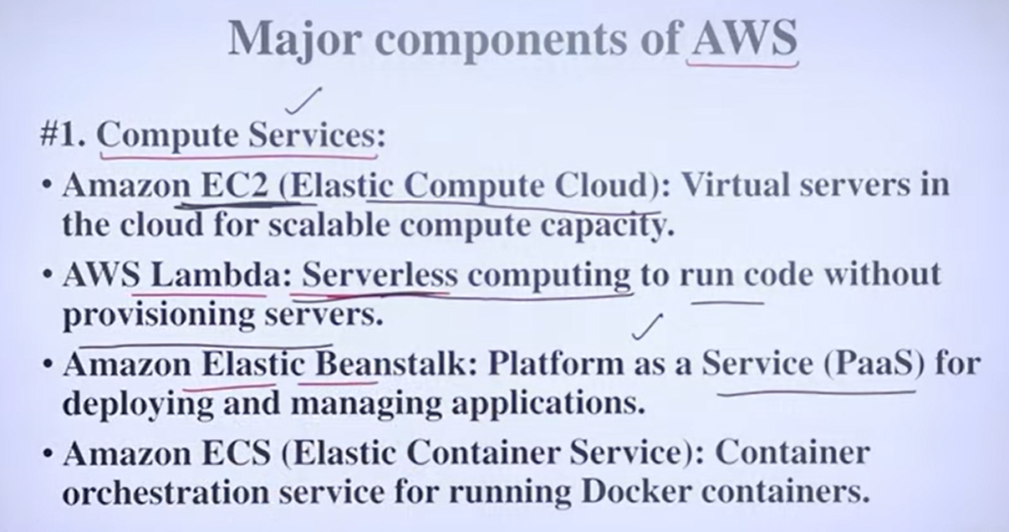This video provides an overview of the major components of AWS Cloud, categorizing them into different service areas.

Here's a summary of the key components discussed:

* **AWS Compute Services**: These services provide the processing power to run applications and websites.
  + **Amazon EC2 (Elastic Compute Cloud):** Allows users to create virtual servers to run dynamic code for websites and applications.
  + **AWS Lambda:** Enables serverless computing, where code can be run without provisioning servers, ideal for tasks like sending confirmation messages or emails.
  + **Amazon Elastic Beanstalk:** Offers a Platform as a Service (PaaS) solution, allowing users to deploy code without managing servers, handling building, deployment, and scaling automatically.
  + **Amazon ECS (Elastic Container Service):** Supports containerization, enabling faster deployment using Docker images.
* **AWS Storage Services**: Essential for storing various types of data.
  + **Amazon S3 (Simple Storage Service):** Used for storing static data like HTML files, images, videos, and large datasets.
  + **Amazon EBS (Elastic Block Store):** Provides block-level storage volumes for use with EC2 instances, working in parallel to store and quickly access data like images and videos.
  + **Amazon Glacier:** Designed for archiving data that is not frequently accessed, offering a cost-effective long-term storage solution.
* **AWS Database Services**: Manage different types of databases.
  + **Amazon RDS (Relational Database Service):** Used for storing and managing structured data in tables, suitable for relational databases.
  + **Amazon DynamoDB:** A NoSQL database service used for unstructured data, providing flexibility for various data models.
* **Networking & Content Delivery**: Focuses on how applications and data are accessed over the network.
  + **Amazon VPC (Virtual Private Cloud):** Allows users to create isolated network environments (public and private subnets) to enhance security and manage traffic.
  + **Amazon CloudFront:** A content delivery network (CDN) that caches frequently requested data at edge locations closer to users, improving data access speed.
  + **AWS Route 53:** Acts as a DNS (Domain Name System) service, translating domain names into IP addresses to route user requests to the appropriate servers.
* **Security, Monitoring & AI Tools**: Cover essential aspects of cloud management.
  + **AWS IAM (Identity and Access Management):** Manages user access, credentials, authorization, and auditing to ensure secure access to AWS resources.
  + **AWS Shield:** Protects against DDoS attacks, using firewalls and other measures to safeguard against cyber threats.
  + **Amazon CloudWatch & CloudTrail:** Tools for monitoring system performance, tracking requests, and managing cloud resources.
  + **Developer Tools (e.g., AWS CodePipeline, CodeBuild):** Support DevOps practices by automating continuous integration and continuous delivery (CI/CD) pipelines, streamlining development and deployment.
  + **Machine Learning (ML) Tools (e.g., Amazon SageMaker, Rekognition):** Provide infrastructure and services for building, training, and deploying ML models, including capabilities for text, image, and video analysis.

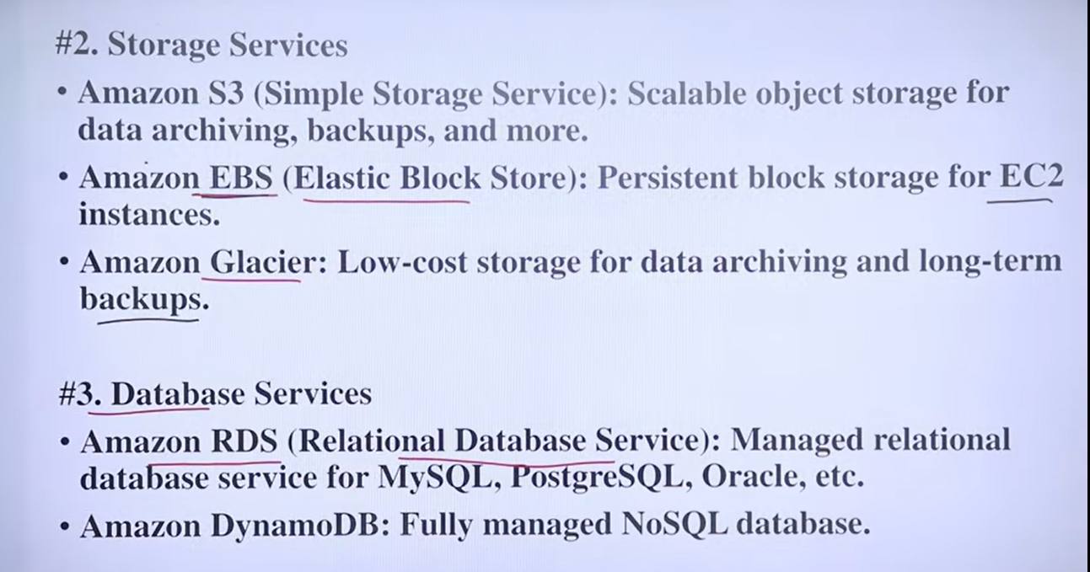

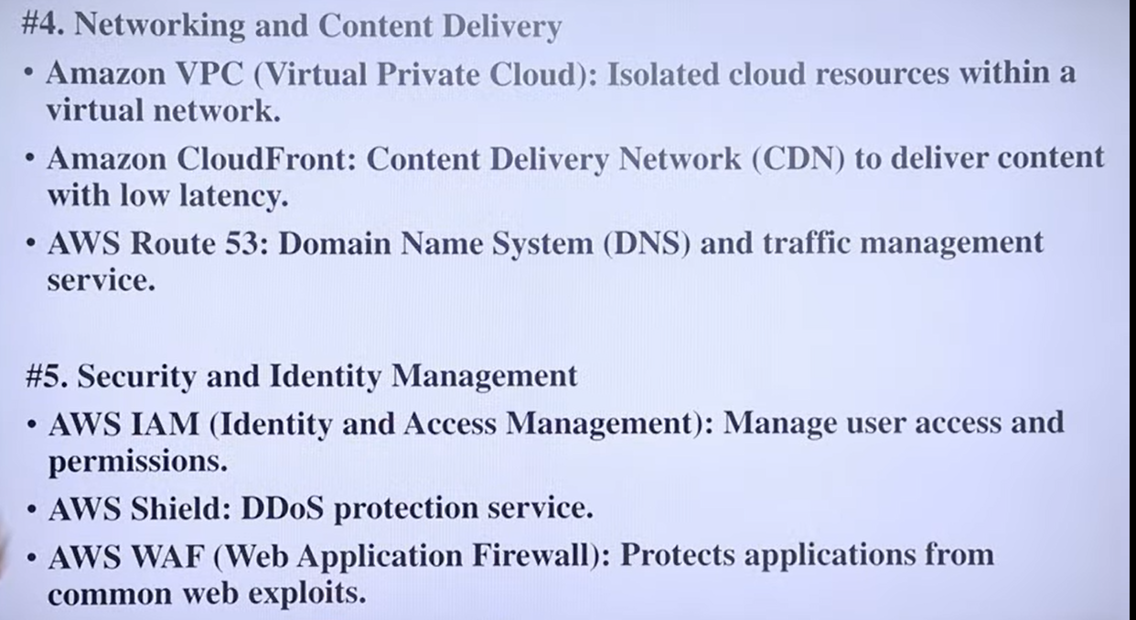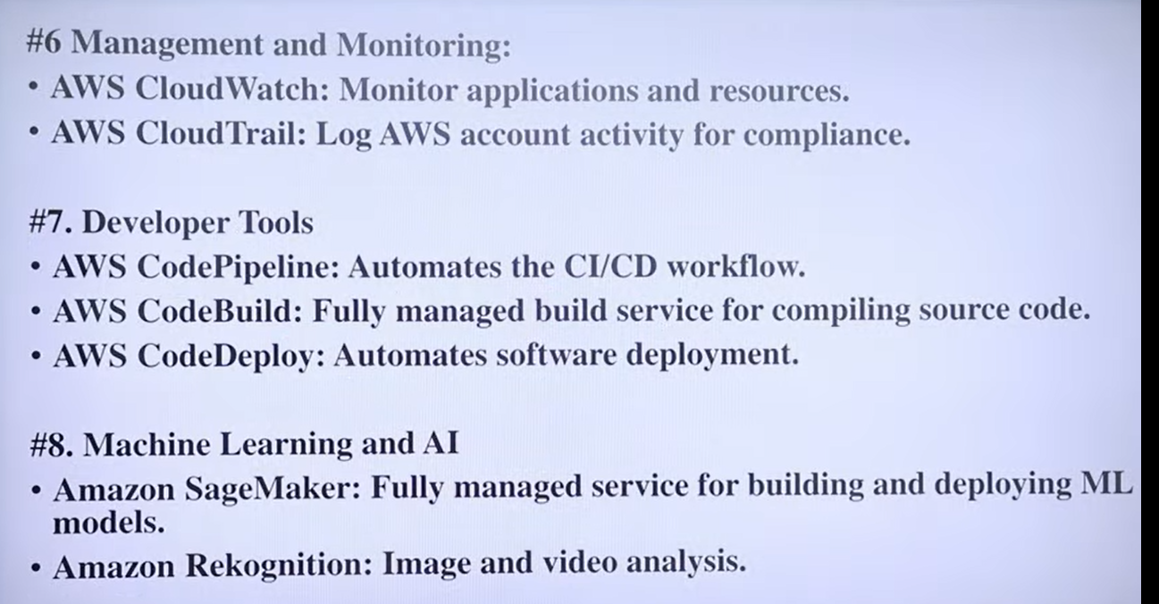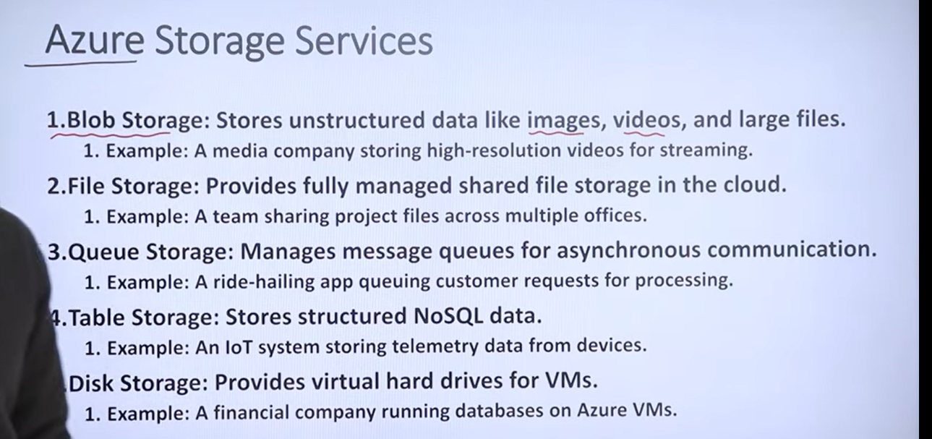This video provides an in-depth explanation of cloud storage architecture, specifically using **Microsoft Azure Storage** as an example.

Here's a summary of the key concepts discussed:

* **Introduction to Cloud Storage** : Cloud storage is a major service in cloud computing, alongside computing and networking. Its primary purpose is to store massive amounts of data, manage it efficiently, provide performance, ensure scalability, and offer quick data backup in case of disasters. Cloud storage employs proper strategies to manage data based on its type and access patterns.
* **Types of Storage in Azure**: Azure provides five main types of storage services, each designed for specific data varieties:
  + **Blob Storage**: Used for unstructured data like images, videos, and binary data.
  + **File Storage**: Designed for various file types, especially for sharing files among different offices or remote workers.
  + **Queue Storage**: Manages message queues for asynchronous communication, essential for handling a large volume of requests like ride-sharing bookings.
  + **Table Storage**: For storing NoSQL data in key-value pairs, often used for IoT sensor data.
  + **Disk Storage**: Specifically designed for structured data, similar to SQL databases.
* **Importance of Redundancy in Cloud Storage**: Redundancy is the most critical factor in cloud storage. Azure's policy mandates at least three copies of data within a single region (intra-region) across different zones and data centers to ensure availability even if a disaster occurs. Additionally, copies are maintained across different geographical regions (inter-region) for maximum resilience. The goal is to achieve high data availability, often aiming for "nine nines" (99.9999999%) uptime.
* **Tier-based Data Management**: Data is categorized into different tiers based on its access frequency to optimize storage costs and performance:
  + **Hot Tier**: For frequently accessed data, stored on fast storage like SSDs for quick retrieval.
  + **Cold Tier**: For less frequently accessed data (e.g., accessed every few days or weeks), stored on slightly slower but more cost-effective storage.
  + **Archive Tier**: For rarely accessed data (e.g., not accessed for a year), stored on the most cost-effective storage like magnetic tapes. This tier helps save money on infrastructure.

The speaker concludes by noting that while the examples are specific to Azure, the core concepts apply to other cloud providers like AWS and GCP, though the exact terminology might differ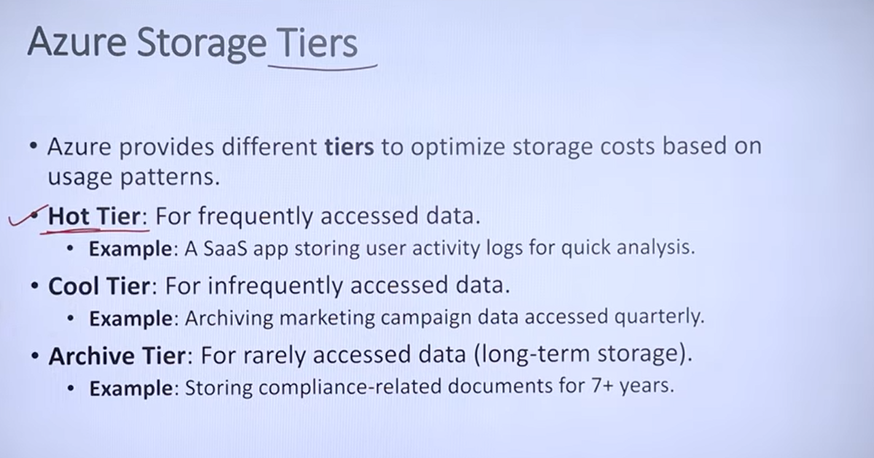This video provides a detailed explanation of **OS Virtualization**, focusing on its definition, practical examples, the role of the hypervisor, and its numerous benefits.

Here's a breakdown of the key topics:

* **Introduction to OS Virtualization**: The video begins by introducing the concept of OS virtualization as a superior method compared to dual-booting or using live USBs for running multiple operating systems on a single machine. It highlights the use case for companies that want to share resources efficiently.
* **Definition of OS Virtualization**: OS virtualization is defined as the creation of virtual instances of operating systems that run concurrently on the same physical machine, emphasizing the key difference from dual-booting where only one OS runs at a time. It also stresses the importance of isolation between these virtual instances.
* **Example using Oracle VirtualBox**: The video provides a practical example using Oracle VirtualBox, illustrating how a user can run multiple guest operating systems (like Linux, Mac, or Ubuntu) on a host Windows operating system within their laptop. This demonstrates the concurrent execution of different OS instances.
* **Role of Hypervisor Explained**: The hypervisor is introduced as a crucial component in virtualization, acting as a "manager" that allocates resources to different operating systems, ensuring they run smoothly and independently. Examples like Hyper-V and VirtualBox are mentioned as open-source hypervisors. A key benefit highlighted is the **isolation** provided, where a crash in one virtual machine does not affect others.
* **Benefits of OS Virtualization**: The video concludes by outlining the significant advantages of OS virtualization, including:
  + **Cost Efficiency**: Reducing the need to purchase new hardware for every application.
  + **Efficient Resource Utilization**: Maximizing the use of CPU and other resources.
  + **Scalability**: Easily configuring and scaling existing hardware without new purchases.
  + **Flexibility and Portability**: Easy migration and replication of virtual machines.
  + **Testing Environments**: Providing isolated environments for testing different modules or applications.

. 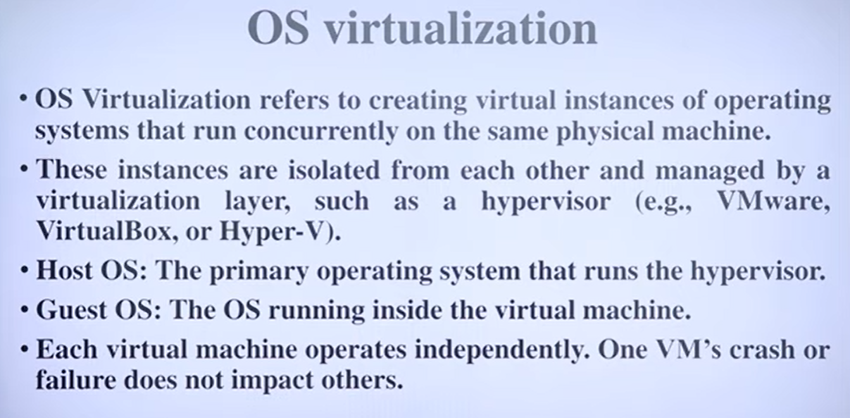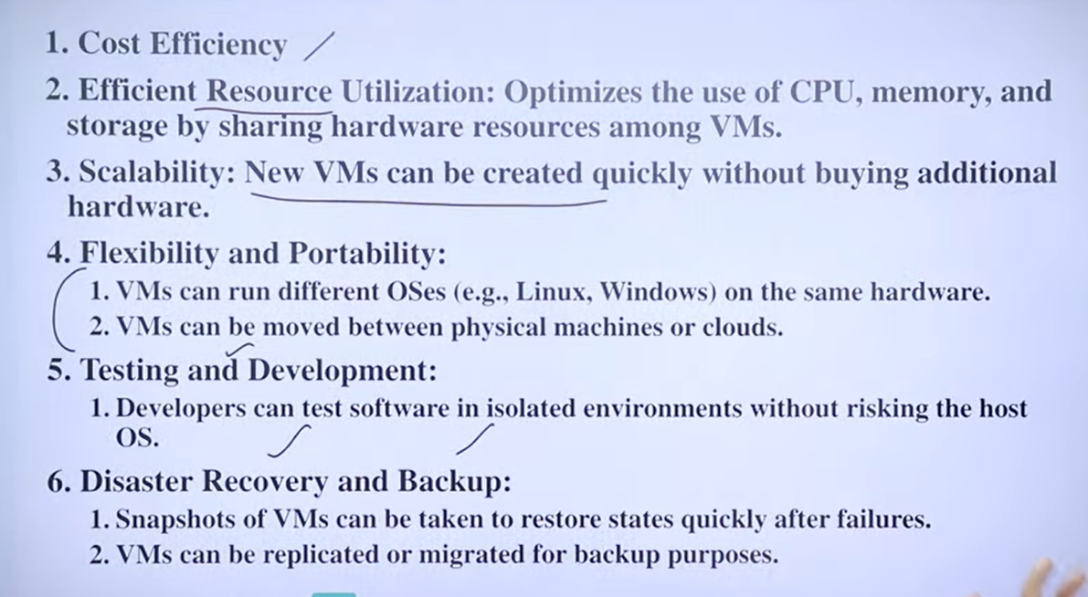

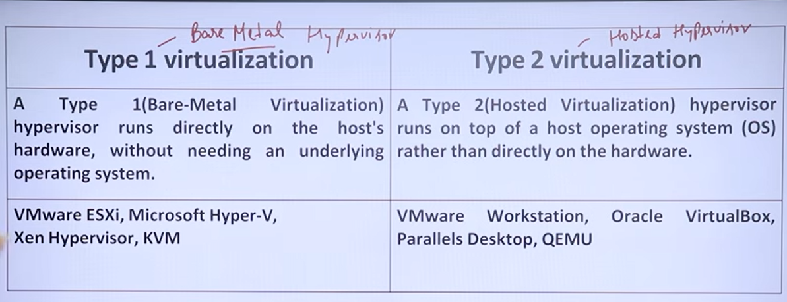

This video explains the two main types of hypervisors used in cloud computing: **Type 1 (Bare-Metal)** and **Type 2 (Hosted)** virtualization.

Here's a summary of the key differences:

* **Type 1 Hypervisor (Bare-Metal Virtualization)**:
  + Runs directly on the underlying hardware without a host operating system.
  + The hypervisor directly manages hardware resources.
  + Multiple virtual machines (VMs) run on top of the hypervisor, each with its own operating system and applications.
  + **Advantages:** Offers higher performance, better isolation between VMs, and enhanced security due to fewer layers.
  + **Use Cases:** Primarily used in enterprise environments and by cloud providers for their data centers where high isolation and performance are crucial.
  + **Examples:** VMware ESXi, Microsoft Hyper-V, Citrix XenServer.
* **Type 2 Hypervisor (Hosted Virtualization)**:
  + Runs on top of a host operating system (like Windows or Mac), which then manages the hardware .
  + The hypervisor is an application installed on the host OS (2:43).
  + Multiple virtual machines are created and run on this hypervisor (2:51).
  + **Advantages:** Easier to set up and use, making it suitable for personal use and testing (4:32).
  + **Disadvantages:** Generally has lower performance and potentially less security compared to Type 1 due to the additional host OS layer, which can introduce vulnerabilities (3:57, 4:51).
  + **Examples:** Oracle VirtualBox, VMware Workstation, Parallels Desktop (3:26).

Why is Type 1 virtualization complex?

How does Type 1 boost security?

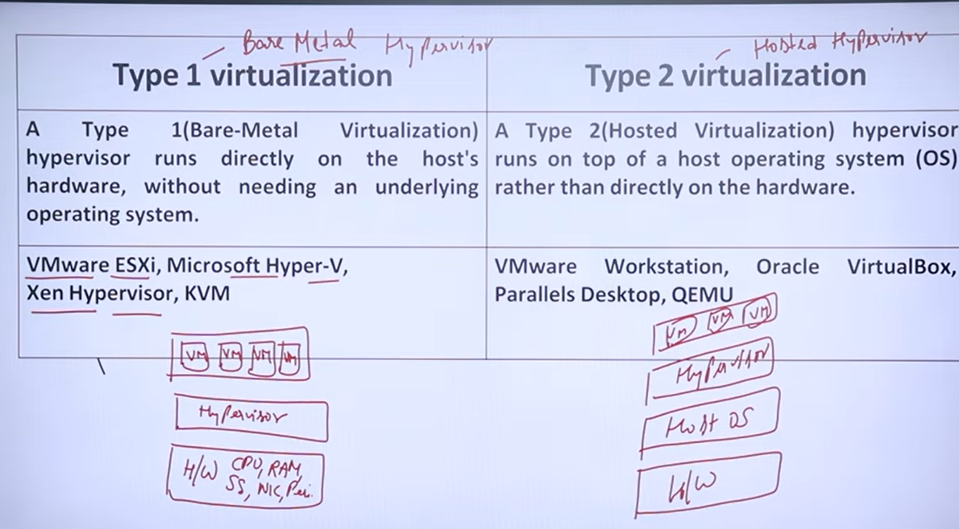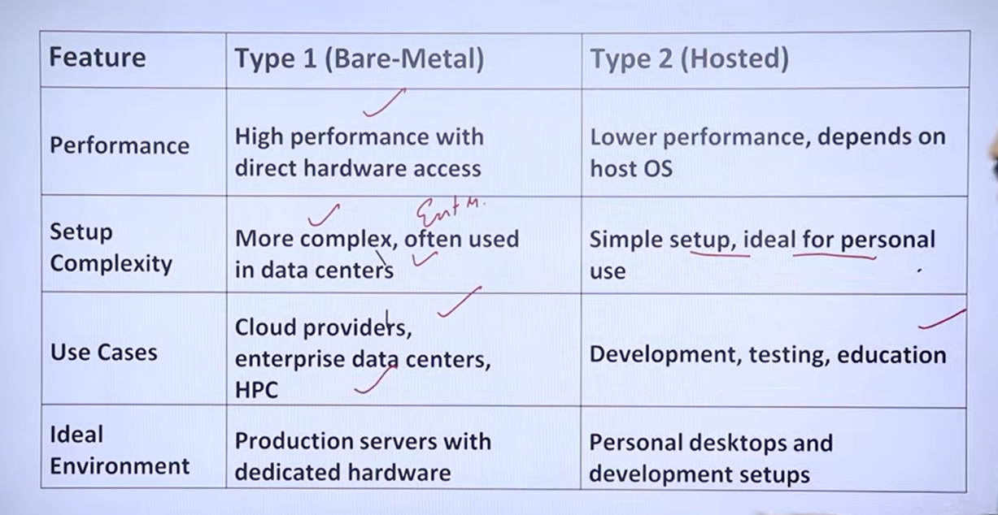This video provides an in-depth explanation of what a hypervisor is, its real-life analogy, and its types.

**Key points covered in the video:**

* **What is a Hypervisor?** A hypervisor is a software layer that enables virtualization by allowing multiple operating systems to run on the same physical hardware, known as a host machine (0:27). It acts as a middle layer, interacting with hardware resources like CPU, memory, and networking, and providing them to multiple virtual machines (1:18). This efficient resource utilization is crucial for cloud computing (1:13).
* **Real-Life Analogy:** The video uses an analogy of a multi-story building on a piece of land, where the land is the host machine, the building is the hypervisor, and each floor or apartment represents a virtual machine. The building's manager (hypervisor) handles common amenities like electricity and water for all residents (virtual machines) (2:26).
* **Types of Hypervisors:** There are two main types of hypervisors (4:40):
  + **Type 1 (Bare-Metal/Native):** This type runs directly on the host machine's hardware, without an underlying operating system (4:51). It is commonly used at the enterprise level for better performance and security (5:48). Examples include VMware and Microsoft Hyper-V (4:24).
  + **Type 2 (Hosted):** This type runs as an application on top of an existing operating system (5:13). It's more suitable for personal use or development environments (6:02). An example is Oracle VirtualBox (6:15).

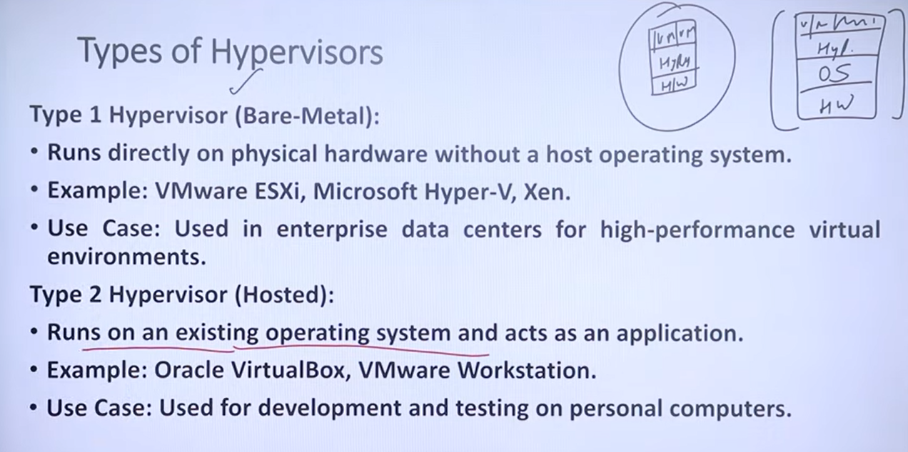This video explains **Cloud Computing** as providing on-demand services over the internet (0:23-0:31).

Here's a breakdown of the key points:

* **Problem with traditional IT infrastructure:** The video highlights the issues businesses face with traditional in-house IT infrastructure, such as high costs for hardware, maintenance, power, and the need for a dedicated tech team (1:04-1:21). This often leads to underutilized resources and financial losses (1:24-1:26).
* **Cloud Computing as a solution:** Cloud computing offers a solution by allowing businesses to store data and run applications on remote systems managed by cloud providers (1:31-1:44). This eliminates the need for businesses to handle maintenance, security, tech teams, and recovery themselves, as these are all managed by the cloud provider (1:44-1:49).
* **Key benefits of Cloud Computing:**
  + **On-demand services:** Services are available when needed (2:32-2:36).
  + **Pay-as-you-go model:** Users only pay for the services they consume (2:39-2:51).
  + **Reduced overhead:** Cloud providers handle security, maintenance, and tech support, significantly reducing costs and headaches for businesses (2:51-3:00).
* **Cloud Providers:** Major companies like Amazon Web Services (AWS), Google Cloud, Microsoft Azure, IBM Cloud, and Alibaba Cloud are identified as prominent cloud providers (2:16-2:30).
* **Impact on Businesses and Individuals:**
  + **Businesses and Startups:** Many companies now rely on cloud services for data storage and computing, making their operations more efficient (3:00-3:14).
  + **Coders and Programmers:** Online coding tests are given on platforms that utilize cloud services, ensuring consistent performance regardless of the user's local system (3:14-3:51).
  + **General Users:** Services like Google Photos demonstrate cloud computing in everyday life by allowing users to store photos online, freeing up device memory and enabling easy access from anywhere (3:57-4:27).

In essence, cloud computing offers a cost-effective and efficient way to manage IT resources, reducing the burden on businesses and providing convenient services to individual users (4:30-4:44).

This video provides a basic introduction to cloud computing, explaining its definition, real-life examples, major providers, and key characteristics.

Here's a summary of the video:

* **Introduction to Cloud Computing** (0:00-0:36): Cloud computing is defined as delivering computing services like storage, servers, databases, networking, software, and virtualization over the internet or "the cloud."
* **Real-Life Examples** (0:36-4:34):
  + **Google Drive** (0:36-1:02): It's used as an example of cloud storage where users can access their data from anywhere with an internet connection.
  + **E-bike Business Scenario** (1:04-4:04): The speaker uses an analogy of an e-bike manufacturer in Chandigarh wanting to expand nationally and internationally. Instead of purchasing and managing their own IT infrastructure (servers, storage, network), which would be costly and require IT expertise, they can leverage cloud computing services like "Software as a Service" (SaaS) to easily manage data and expand their reach.
  + **Netflix and Music Streaming** (4:04-4:28): Netflix and music streaming services are presented as prime examples of cloud power, where content is streamed directly to devices without needing to be downloaded, requiring only an internet connection.
* **Major Cloud Providers** (4:34-5:40): The video lists major cloud providers in the world, including:
  + Amazon Web Services (AWS) (4:37)
  + Microsoft Azure (4:38)
  + Google Cloud Platform (GCP) (4:40)
  + Alibaba Cloud (4:41)
  + IBM Cloud (5:01)
  + Oracle Cloud (5:02)
  + Salesforce (5:03)
  + Tencent Cloud (5:04)
  + Dell Cloud (5:04)
  + VMware Cloud (5:05)
  + SAP (5:06)
* **Key Characteristics of Cloud Computing** (5:40-8:42):
  + **On-Demand Self-Service** (5:46-6:15): Users can easily acquire computing resources like storage or computation as needed, similar to purchasing iCloud storage for photos and videos.
  + **Pay-as-You-Go Service (Metered Service)** (6:15-6:56): Users only pay for the services they consume, much like paying for an Ola ride based on the distance traveled.
  + **Broad Network Access** (6:56-7:06): Cloud services can be accessed from any device, anywhere in the world, with an internet connection.
  + **Resource Pooling** (7:06-7:46): Resources are pooled and shared among multiple users, giving the impression of dedicated resources even though they are logically provided, similar to how a hotel's swimming pool is shared by all guests.
  + **Scalability and Elasticity** (7:48-8:32): Cloud computing allows businesses to easily scale their resources up or down based on demand, enabling them to handle sudden increases in requests (e.g., from 1,000 to 100,000 or even 10 crore requests), as cloud providers have massive computing resources available.

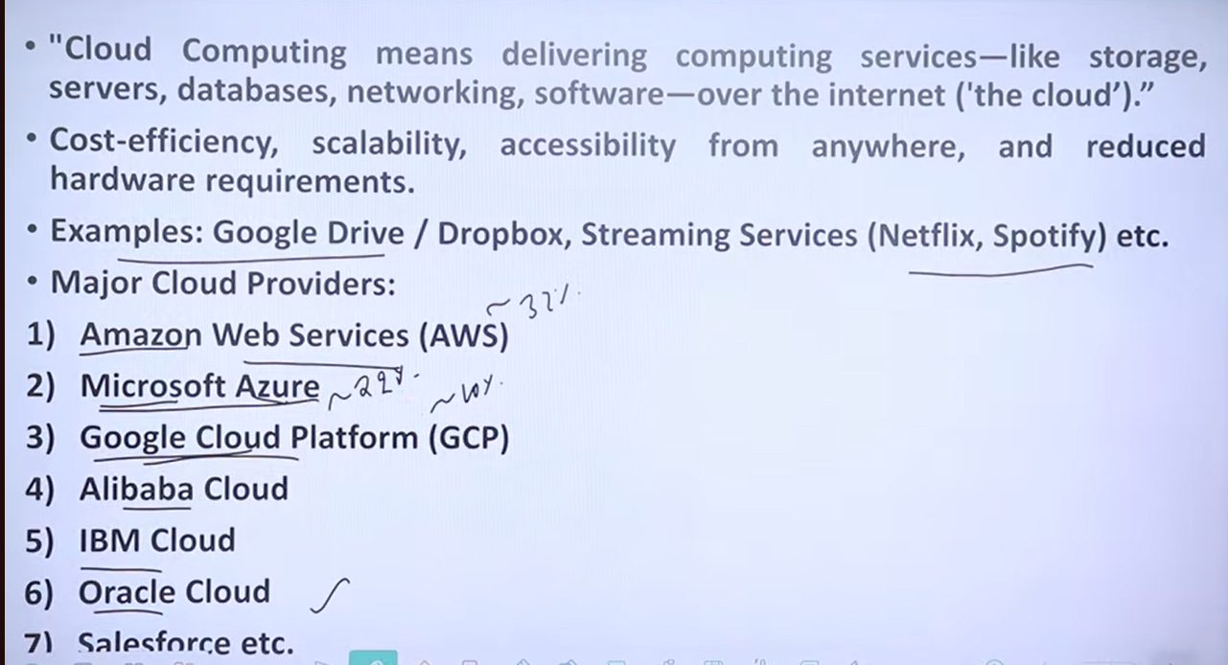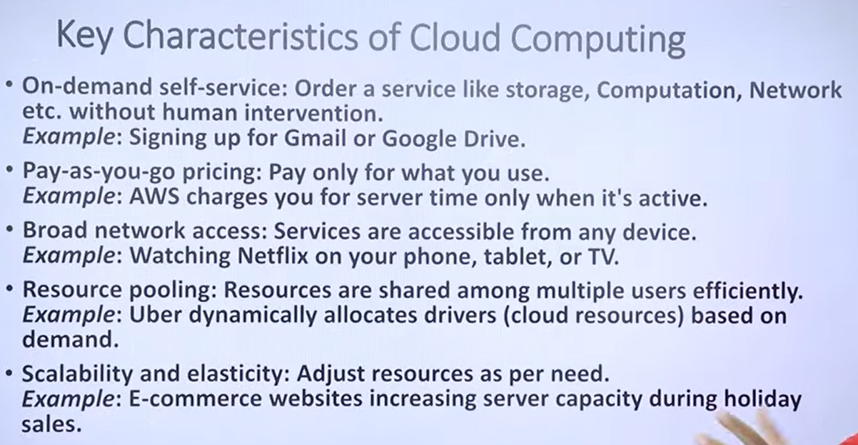

This video provides an overview of Amazon ECS and EKS, both Amazon technologies for container orchestration, and helps users choose the right one for their needs (0:00).

Key takeaways from the video include:

* **Amazon ECS (Elastic Container Service):**
  + A container orchestration service for deploying, managing, and scaling containerized applications (0:17).
  + **Features:** Runs on Amazon, allows managing instances or going serverless, uses CloudWatch for monitoring and logging, and manages access with IAM (0:25).
  + **Advantages:** Easy to set up and learn, has fewer components, and doesn't require managing control plane nodes or add-ons (0:35).
  + **Best for:** Simple architectures, minimal maintenance, and low cost (2:22).
  + **Case Study:** Prime Video uses Amazon ECS to manage tasks and capacity, automatically scaling up to 6,000 containers during peak events (2:29).
* **Amazon EKS (Elastic Kubernetes Service):**
  + A managed Kubernetes service that runs on Amazon, leveraging Kubernetes as an open-source system for deploying, managing, and scaling containerized applications (0:45).
  + **Features:** Runs on Amazon, allows managing instances or going serverless, uses CloudWatch for monitoring and logging, and manages security with IAM and RBAC (0:51).
  + **Advantages:** Easy to use if familiar with Kubernetes, offers full flexibility in architecture, allows managing control plane nodes and add-ons, and uses service mesh for complex routing (1:05).
  + **Best for:** Complex architectures due to its wide range of features, high maintenance, and full flexibility (2:44).
  + **Case Study:** A CTO noted EKS's ease and reliability, allowing them to start new Kubernetes clusters within minutes, providing a better testing and performing platform (2:57).
* **Comparison of Components (1:20):**
  + Both services require a **cluster** (1:23), which is a logical grouping of components, powered by EC2 instances or Fargate (1:30).
  + Inside the cluster, one or more **services** run, containing configurations for the application (1:37).
  + **Task Definition (ECS)** and **Deployment (EKS)** are sets of instructions defining containers, their image, environment variables, CPU, and memory (1:46).
  + The simplest unit is a **task (ECS)** or **pod (EKS)**, which is the actual running container(s) that can be scaled, deleted, or modified (2:02).

This video provides a high-level overview of containers, their benefits, and how they are used in AWS.

The video starts by explaining **what containers are** (0:22) and how they solve problems like dependency and configuration issues when deploying applications (0:27-1:02). It then **compares containers to virtual machines**, highlighting that containers are more lightweight and faster to start because they share the host operating system, unlike VMs which require their own OS (1:04-3:44).

The video introduces **Docker** (3:55), the most popular container technology used by AWS, and defines Docker images (read-only templates) and Docker containers (running instances of images) (3:59-4:28).

Finally, the video describes **AWS container services**:

* **Amazon Elastic Container Service (ECS)** (4:47): A proprietary AWS service for running, stopping, and managing Docker containers.
* **Amazon Elastic Kubernetes Service (EKS)** (5:15): A managed service for running Kubernetes, an open-source container orchestration platform, on AWS.
* **Launch types for containers** (5:58):
  + **EC2 instances** (6:07): Users provision and maintain the underlying EC2 instances.
  + **Fargate** (6:17): A serverless option where AWS manages the underlying infrastructure.
* **Amazon Elastic Container Registry (ECR)** (6:38): A service for storing Docker images, which ECS or EKS then pull from to build containers.

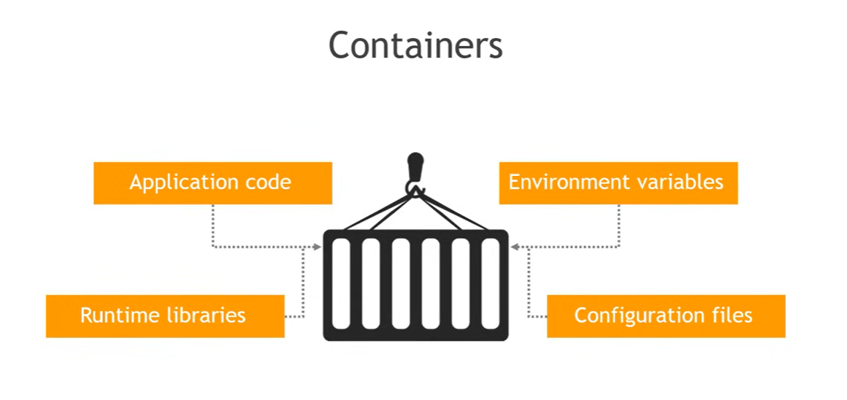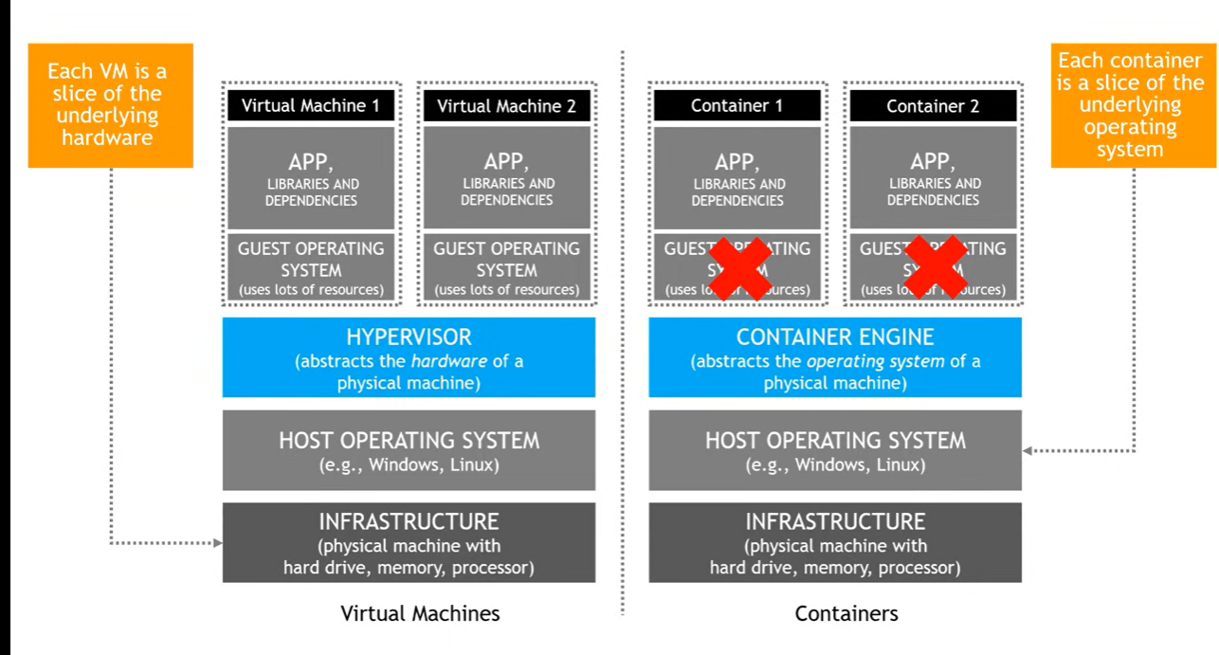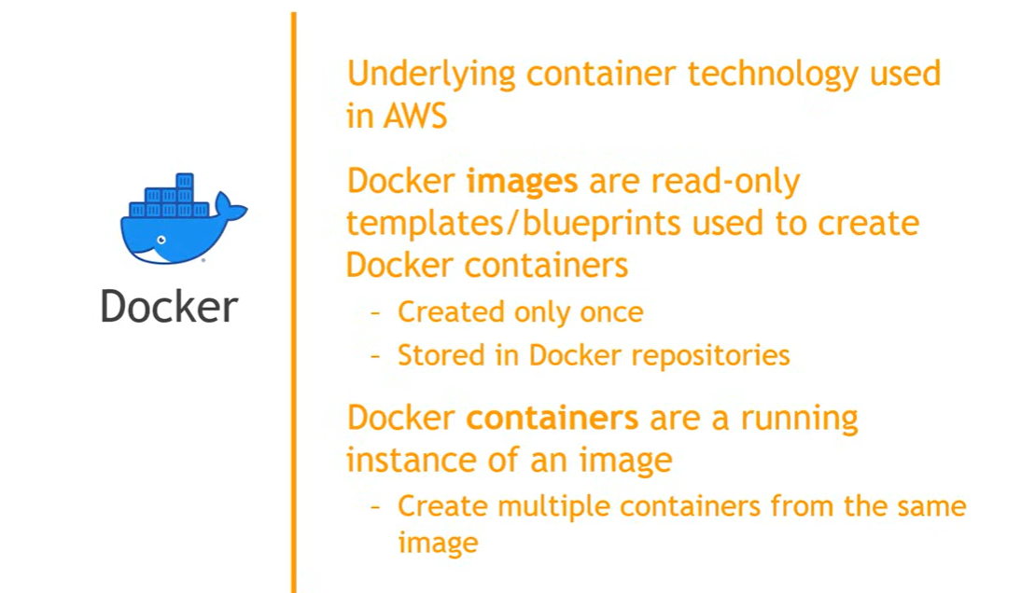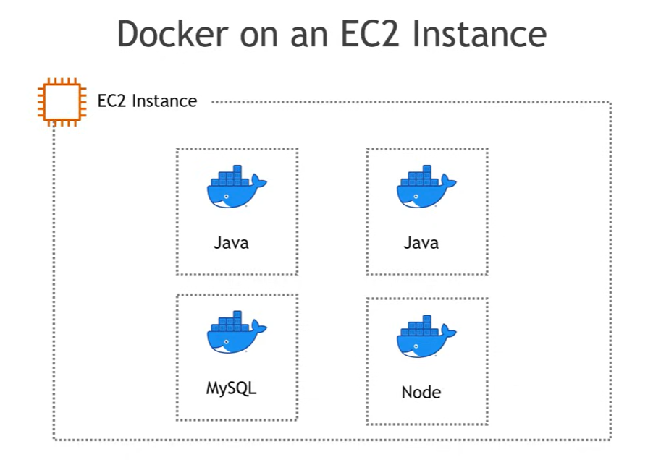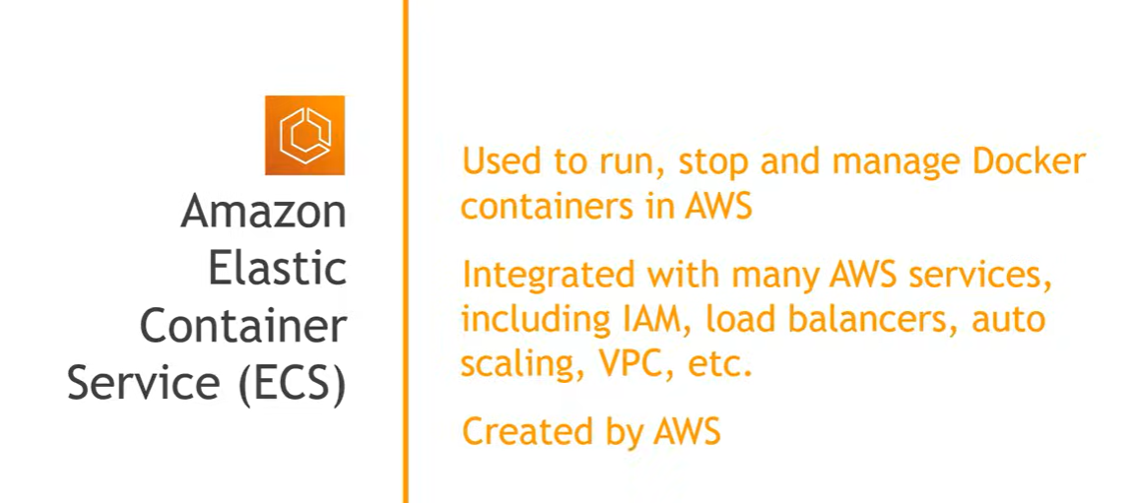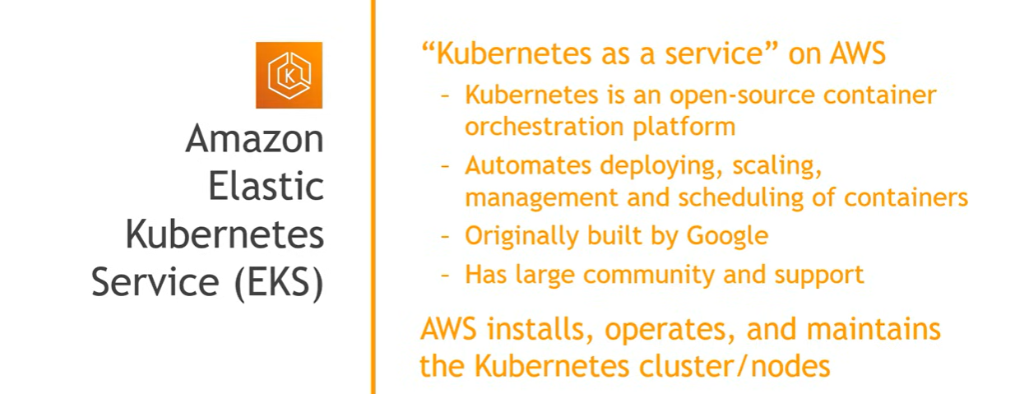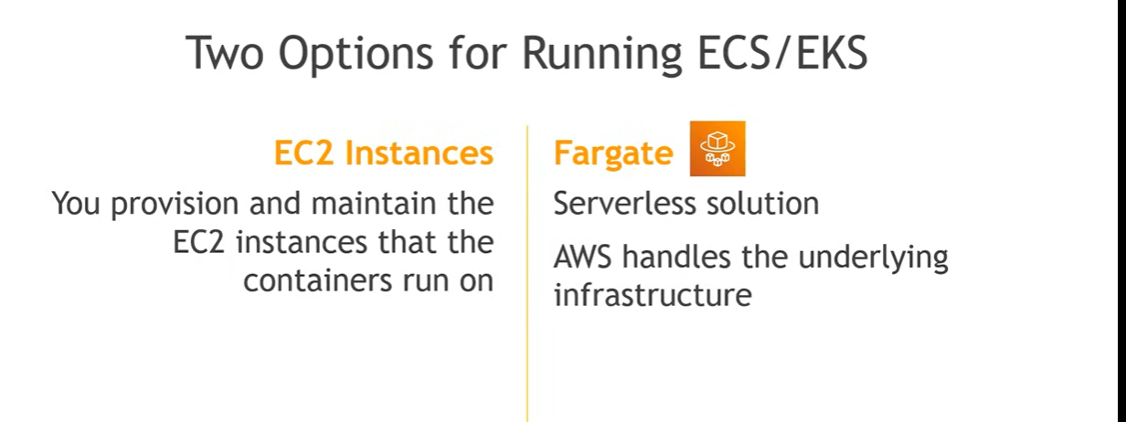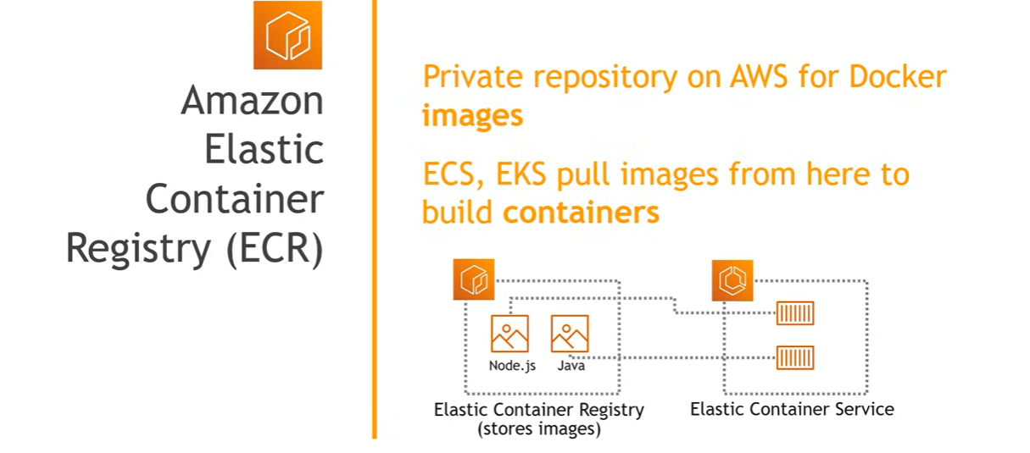This video provides a comprehensive comparison of AWS container orchestration services: **Amazon ECS (Elastic Container Service)**, **Amazon EKS (Elastic Kubernetes Service)**, and **AWS Fargate** (0:05-0:14). The video aims to help users choose the best service for their application needs (0:12-0:14).

Here's a breakdown of the services and their comparisons:

* **Amazon EKS (Elastic Kubernetes Service)**: (1:59-3:14)
  + A fully managed Kubernetes-as-a-service platform that allows deploying, running, and managing Kubernetes applications and workloads on AWS or on-premises.
  + AWS handles the Kubernetes control plane administration tasks, including patching, upgrades, and scaling (2:59-3:14).
  + **Use Cases:** Ideal when your workload runs on Kubernetes but you need a managed service for simplification, require more networking nodes on demand, plan to migrate containerized applications to other Kubernetes-compatible services (GCP, Azure), or already have expertise in deploying and optimizing containers on Kubernetes (7:15-8:32).
* **Amazon ECS (Elastic Container Service)**: (3:17-4:31)
  + AWS's Docker-based container scheduling and orchestration system, built from scratch (3:21-3:35).
  + A fully managed container service that allows users to focus on improving code and service delivery rather than building and maintaining container management infrastructure (3:39-3:58).
  + Defines containers in a task definition to run individual tasks or services within a cluster (4:10-4:31).
  + **Use Cases:** Suitable when most of your workload runs on the AWS ecosystem and you want to run containers at scale with an opinionated AWS solution, need deep integration with AWS services (CodePipeline, ECR), require a fast and easy learning curve, or want to reduce container management costs using spot instances (8:43-9:55).
* **AWS Fargate**: (4:39-5:32)
  + A fully managed serverless compute service that automates most container management tasks (4:41-4:52).
  + It allows setting resource parameters and access control but doesn't allow choosing specific instances or how to scale ECS resources (5:01-5:21).
  + Works as an operational mode for both ECS and EKS (5:36-5:47).
  + **Use Cases:** Use when your existing workload is on serverless technologies or you plan to move to them, if a "less server management" strategy is crucial for productivity and cloud cost, or if you only need container-level permissions and customization for optimal performance (9:58-10:57).

The video also discusses:

* **Comparison of ECS vs. EKS vs. Fargate organization**: AWS container services are organized into registry services (ECR), orchestration services (ECS, EKS), and compute services (EC2, Fargate) (5:51-7:03).
* **ECS on Fargate vs. EKS on Fargate**: (11:00-11:58)
  + EKS on Fargate simplifies running Kubernetes on AWS, while ECS on Fargate simplifies managing Docker containers (11:03-11:28).
  + ECS on Fargate is generally more cost-effective as it utilizes spot instances (11:36-11:58).
  + EKS on Fargate is ideal for serverless apps requiring more than a single networking node (11:59-12:16).
  + ECS on Fargate is suitable for running ad hoc jobs with variable usage (12:19-12:22).
* **Trade-offs of using ECS or EKS on Fargate**: (12:25-13:09)
  + **Limited features**: Sacrifices some configurability and advanced features (12:32-12:50).
  + **Higher cost**: Can be more expensive than managing your own compute, although this is becoming less true as Amazon improves Fargate (12:53-13:36

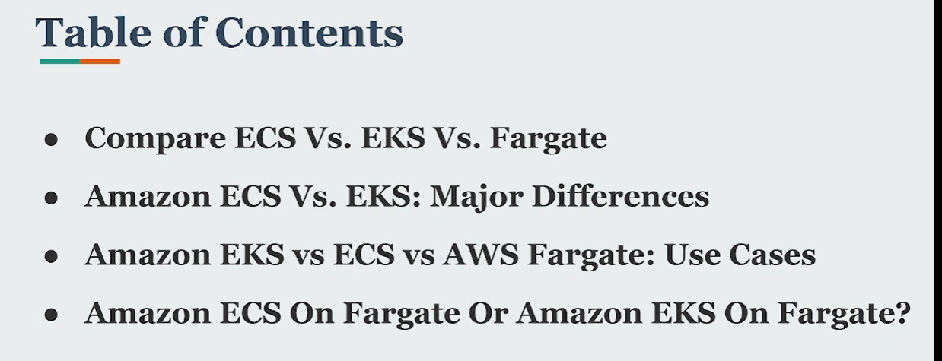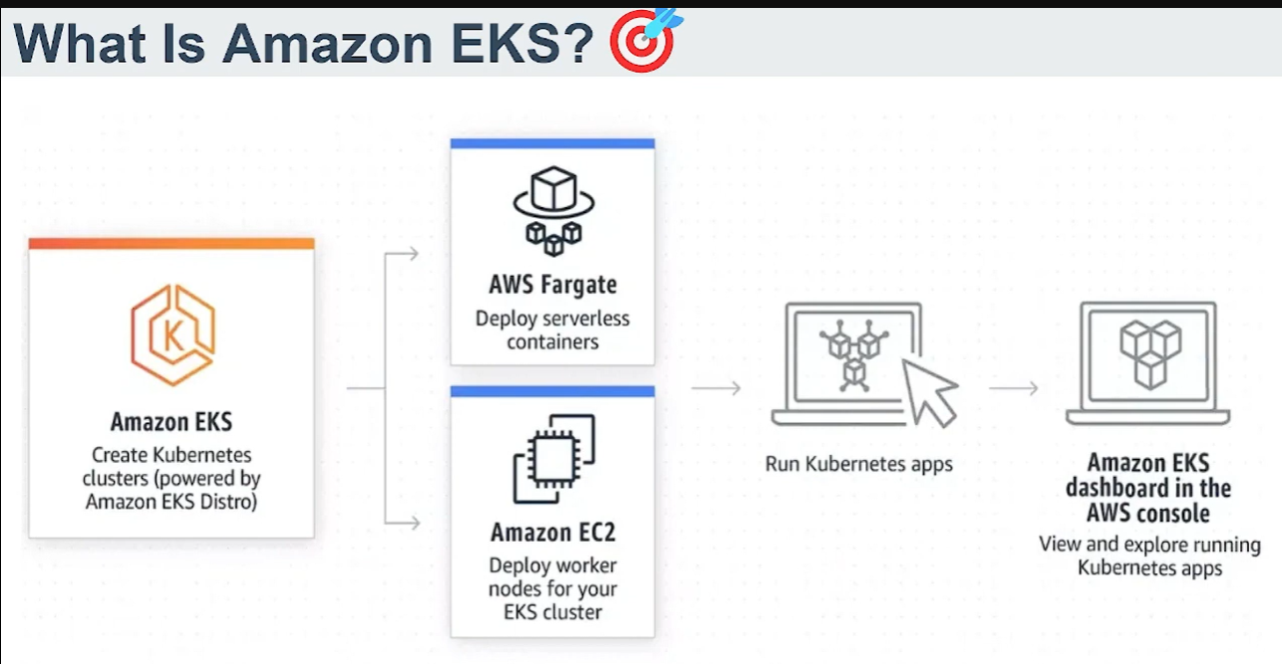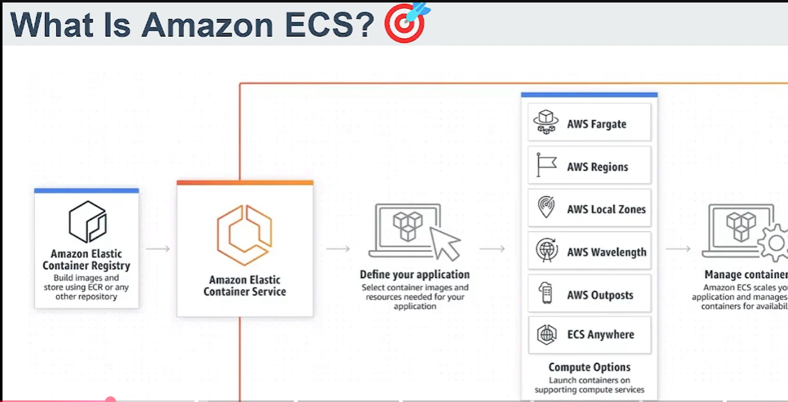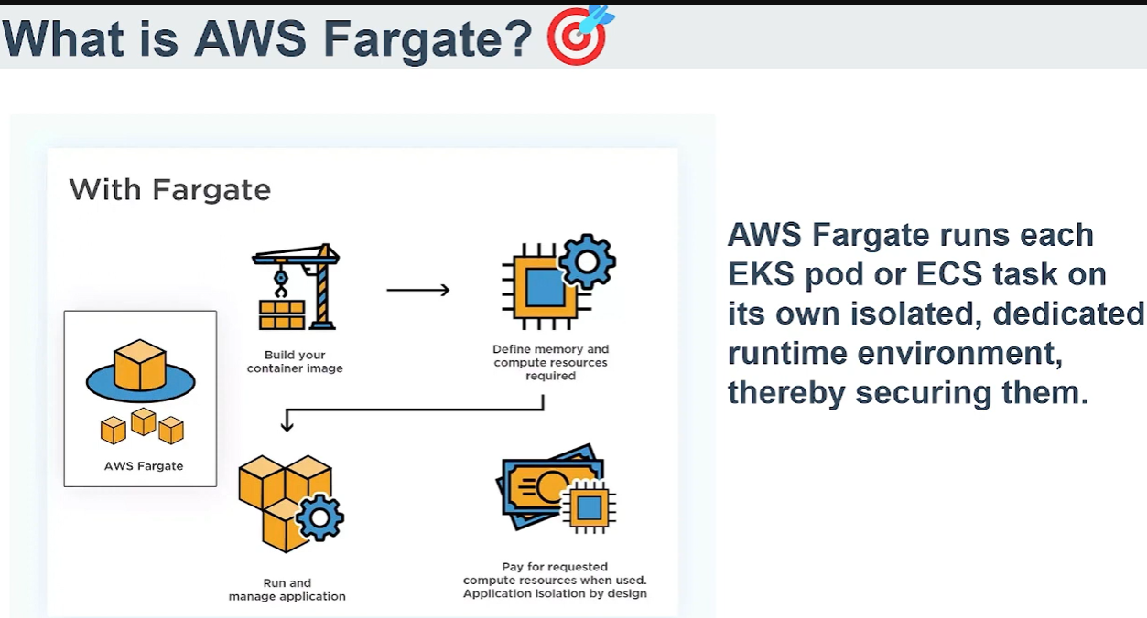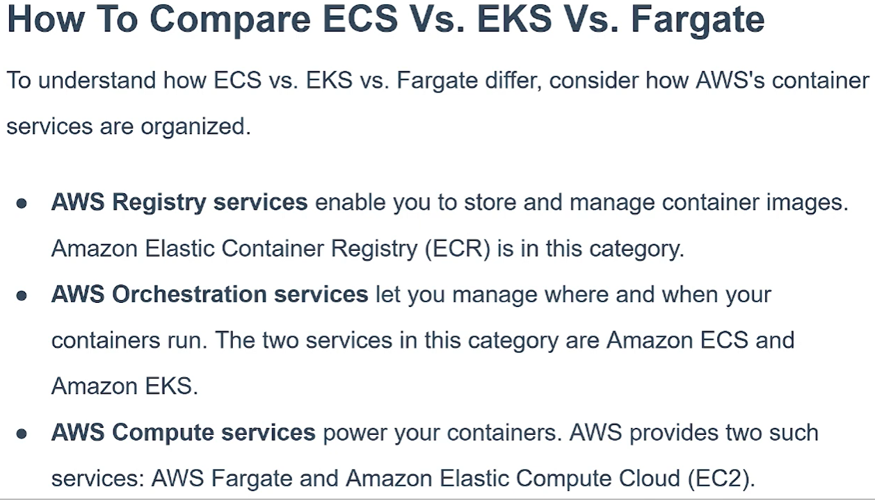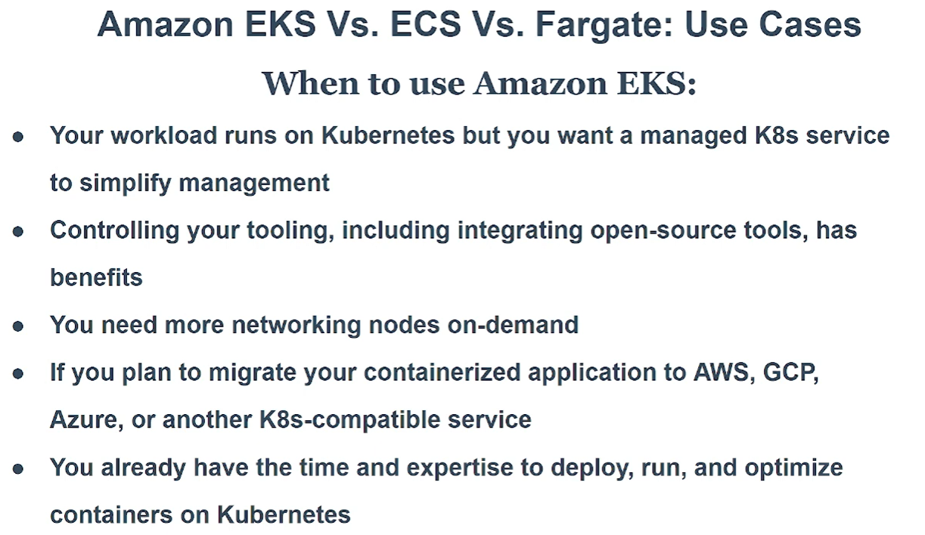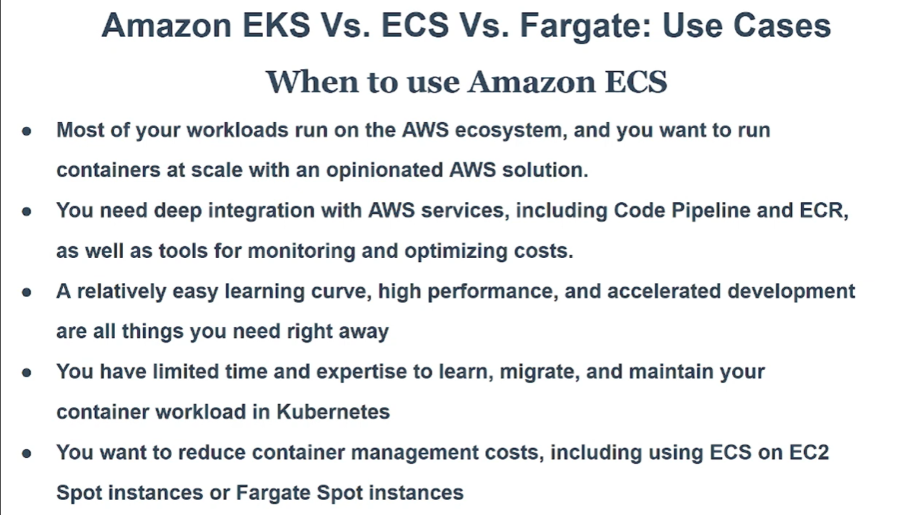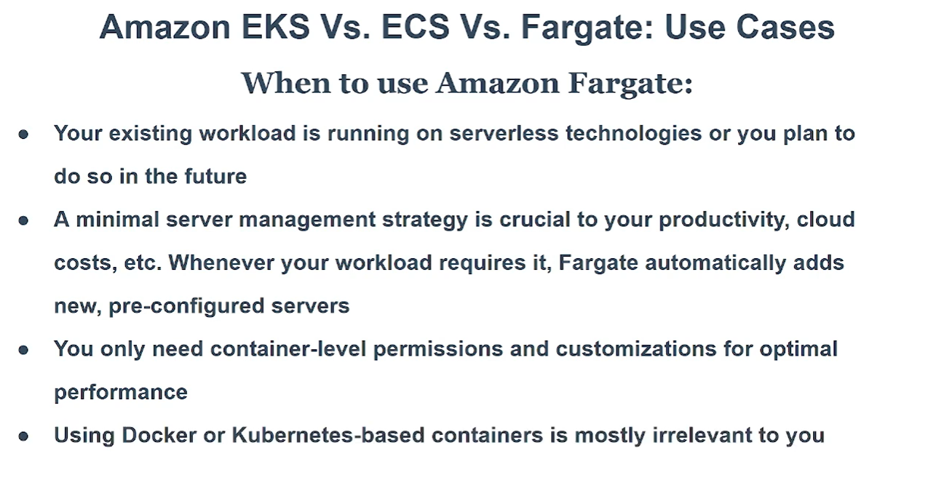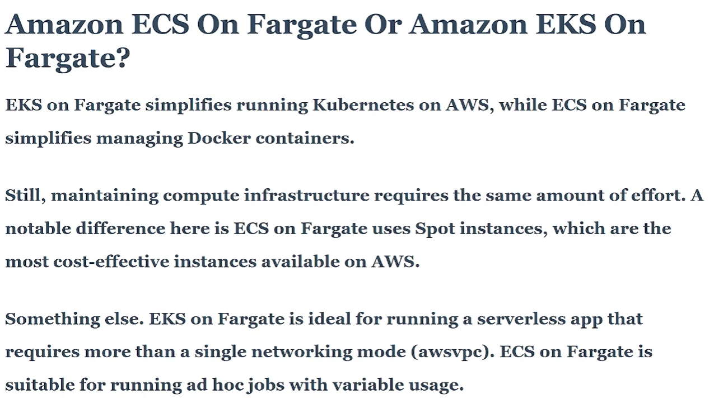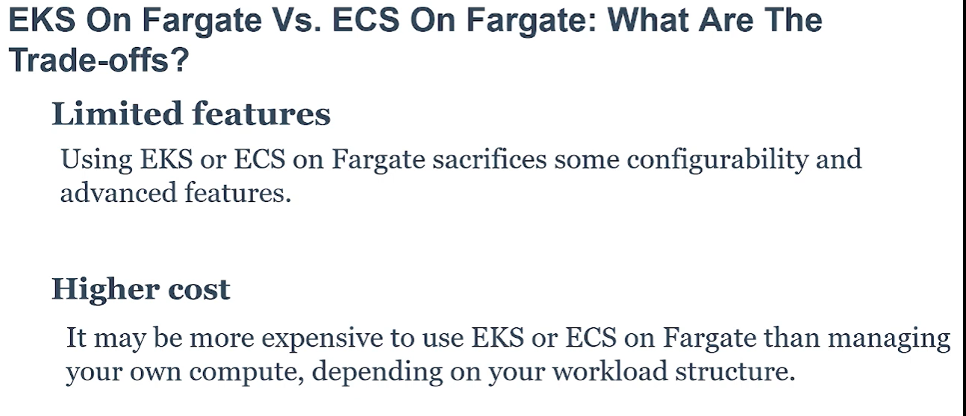This video explains and compares **AWS Fargate, Amazon Elastic Container Service (ECS), and Amazon Elastic Kubernetes Service (EKS)** (0:00-0:13).

Here's a summary of each:

* **AWS Fargate** (0:14-0:32, 1:30-2:01)
  + It is a **fully managed compute engine for running containers** (0:14-0:16, 1:30-1:33).
  + It allows you to run containers **without provisioning and managing the underlying EC2 instances** (0:19-0:22, 1:34-1:36).
  + You only specify the desired number of containers and their resources, and Fargate handles the rest (0:25-0:32).
  + It integrates with other AWS services like Amazon EC2 and Amazon EBS (1:52-1:58).
* **Amazon Elastic Container Service (ECS)** (0:35-0:59, 2:02-2:48)
  + It's a **container orchestration service** for running, scaling, and managing containerized applications on AWS (0:38-0:42, 2:06-2:12).
  + It allows you to run, stop, and manage Docker containers on a **cluster of EC2 instances** (0:46-0:51).
  + ECS integrates with Fargate, allowing you to run ECS tasks and services on Fargate (0:53-0:58).
  + Unlike Fargate, **ECS requires you to manage the underlying infrastructure yourself**, including EC2 instances, storage, and networking (2:25-2:39).
  + It uses its **own proprietary API and management tools** (2:41-2:47).
* **Amazon Elastic Kubernetes Service (EKS)** (1:00-1:28, 2:50-3:31)
  + It is a **fully managed Kubernetes service** for deploying, running, and managing containerized applications on AWS (1:04-1:11, 2:54-2:59).
  + It lets you create and manage a Kubernetes cluster in AWS (1:13-1:18).
  + Like ECS, EKS also integrates with Fargate, allowing you to run EKS pods and containers using EC2 or Fargate (1:20-1:28).
  + Similar to ECS, **EKS requires you to manage the underlying infrastructure** (3:00-3:05).
  + Unlike ECS, EKS uses the **open-source Kubernetes API and management tools**, which are widely used and offer more flexibility and customization, though they may require more Kubernetes knowledge (3:12-3:31).

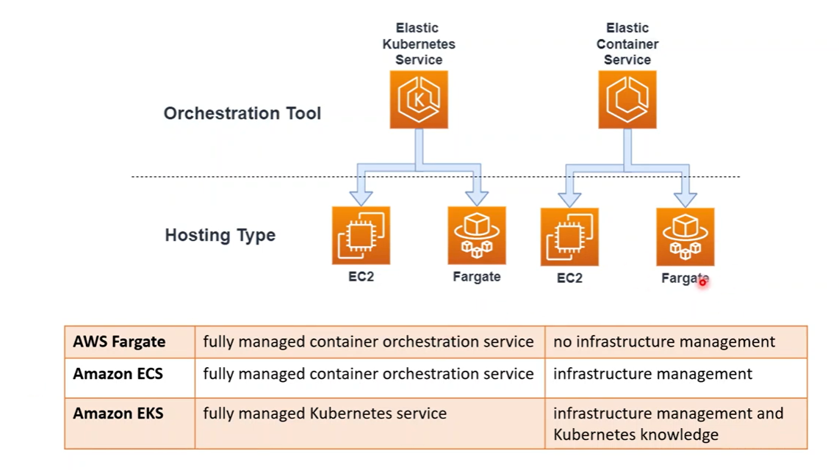This video provides a comprehensive guide to **AWS Elastic Container Service (ECS)**, explaining its core concepts and demonstrating how to run a Docker container using the service.

The video covers the following:

* **What is AWS ECS?** ECS is introduced as a cloud-based container management service that allows users to run and manage Docker containers on a cluster of virtual servers (0:29-1:05). It is highlighted for its ability to automate the creation, management, and updating of containerized applications, reducing manual configuration (1:33-2:16).
* **Key ECS Terms:** The video explains essential terms such as **Cluster**, which groups tasks and services and hosts resources (2:43-2:53), **Service**, which handles scalability and load balancing of container tasks (2:53-3:00), and **Task**, representing a running container (3:00-3:01). It also introduces **Task Definition**, where container configuration details like image, environment variables, and port binding are specified (4:11-4:34).
* **ECS Flow Diagram:** A visual representation of how ECS components interact is provided, showing that a cluster contains services, which in turn manage tasks based on task definitions (4:46-5:14).
* **Practical Demonstration: Running Your First ECS Container:** The video walks through a step-by-step process (5:30) of creating an ECS cluster, defining a task (8:19) for a Nginx application, and creating a service to deploy and run the container (11:39). It emphasizes using the **Fargate launch type** for serverless operation (7:26-8:01) and configuring network settings, including enabling public IP for access (12:40-13:10). The successful deployment of the Nginx web server is demonstrated (14:40).
* **Managing and Deleting ECS Resources:** The video also shows how to update a service, such as changing the number of running instances (15:05-15:47), and crucially, how to **delete all created resources (services, task definitions, and clusters)** to avoid incurring charges (16:11-17:18). The creator notes that ECS is not a free service but costs are minimal for testing purposes (5:42-6:21).

# Virtual Machine vs Containers

This video explains the key differences between **Virtual Machines (VMs)** and **Containers**, two important technologies in cloud computing used for isolating and running applications (0:00).

Here's a breakdown of the concepts discussed:

* **Virtual Machines (VMs) Architecture** (1:00):
  + VMs involve a **physical server infrastructure** (1:00) with a **host operating system (OS)** (2:09).
  + A **hypervisor** (3:30) is then installed, which allows for the creation of **multiple virtual machines (VMs)** on top of the host OS (3:30).
  + Each VM has its own **guest operating system** (4:37), along with the application, its libraries, runtime, and drivers (4:59). This provides strong isolation but makes them heavier.
  + VMs allow for better utilization of server resources by running multiple applications on a single physical machine (3:19).
* **Containers Introduction** (5:25):
  + Containers also start with a **physical server infrastructure** and a **host operating system** (5:37).
  + However, unlike VMs, containers **do not have their own guest operating systems** (7:21).
  + Instead, they package the application code, libraries, drivers, runtime, and dependencies into a self-contained unit (6:18).
  + Container engines like **Docker** are used to create, manage, and monitor these containers (6:47).
* **Key Differences: VMs vs. Containers** (7:19):
  + **Guest OS:** VMs require a separate guest OS for each virtual machine, whereas containers share the host OS (7:21).
  + **Lightweight and Speed:** Containers are significantly **lighter-weight** and **faster to run and execute** compared to VMs because they don't include an entire OS (7:46).
  + **Portability:** Containers are easier to port from one environment to another (8:06).
  + **Security:** While VMs offer strong isolation due to separate guest OSs, containers are also fully secured with their own privacy (8:13-8:22).
  + **Operating System Dependency:** A drawback of containers is that their code must be compatible with the host operating system (8:32-8:49).
  + **Scalability and Management:** Containers allow for the creation of thousands of instances and are easily managed for scaling up or down, and patching, often using tools like Kubernetes for orchestration (9:23-9:39).

The video concludes by highlighting why many companies are now moving towards containerization due to its advantages in speed, portability, and efficient resource utilization (9:06-9:11).

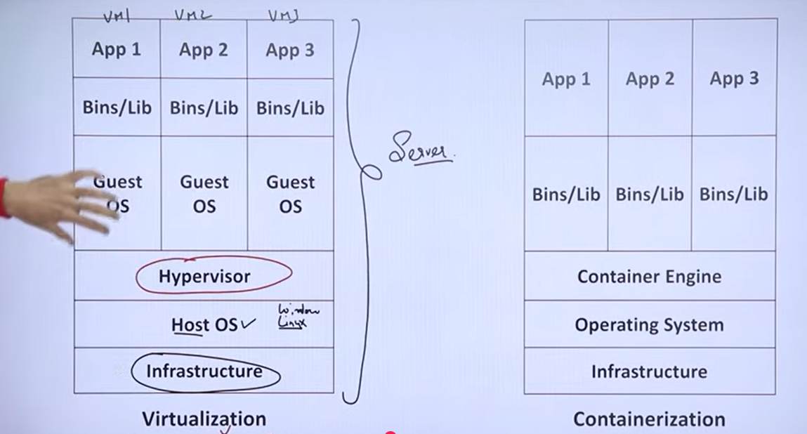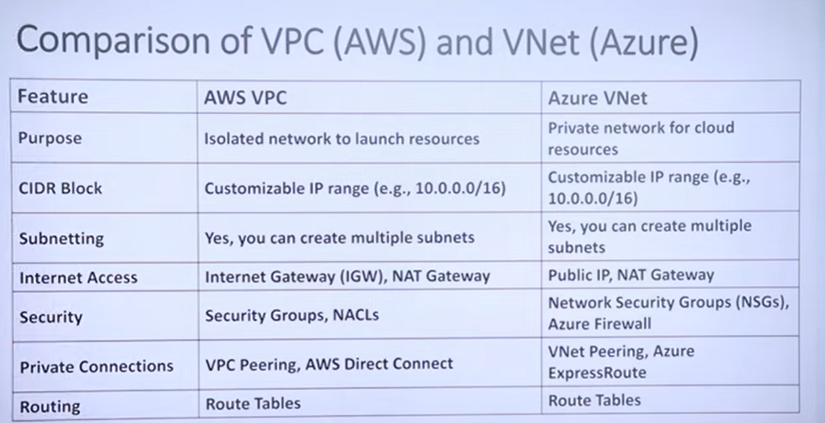This video provides an overview of network configuration in cloud computing, specifically focusing on **Amazon AWS VPC (Virtual Private Cloud)** and **Microsoft Azure VNet (Virtual Network)** (1:33).

Key points covered include:

* **Importance of Cloud Networking:** The video highlights that networking is crucial for hosting websites and applications in the cloud, alongside storage and computation, to ensure security and scalability (0:44).
* **Private Network Creation:** Both AWS VPC and Azure VNet allow companies to create isolated, private networks within the public cloud. This enables them to segment their network, placing public-facing elements like websites on a public subnet and sensitive data like databases on a private subnet for enhanced security (1:07-1:33).
* **Underlying Technology:** Both platforms utilize **CIDR (Classless Inter-Domain Routing)** for IP address allocation and subnetting, which is fundamental for understanding cloud networking (2:09).
* **Security Measures:** The video emphasizes the use of security groups, Network Access Control Lists (NACLs), or Network Security Groups (NSGs) as virtual firewalls to manage inbound and outbound traffic and apply specific rules (3:21).
* **Routing:** Both AWS and Azure use routing tables to direct data traffic within their respective networks (4:13).